Atlanta Parrot Head Club 30th Anniversary Celebration

Our official host hotel is the beautiful
Legacy Lodge at Lanier Islands

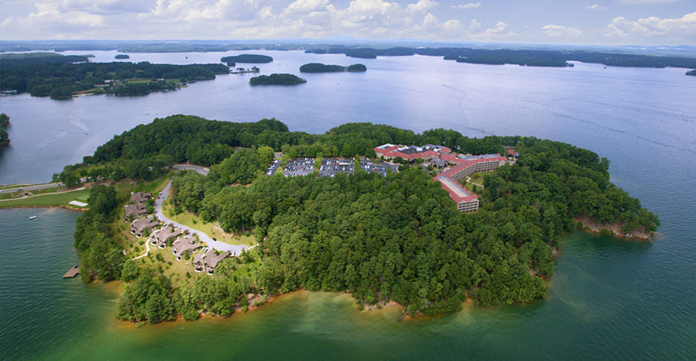
May 5, 2019 Update: The hotel is sold out for our rates.
See the last page for options and more information

Rates

We have arranged fantastic rates exclusively for guests of the Atlanta Parrot Head Club:

- Legacy Lodge Rooms: $169 per night
  - King or Double Queen
- Legacy Villa King: $199 per night
  - Accommodates up to two guests
  - One bedroom with a king bed
- Legacy Villa Double: $199 per night
  - Accommodates up to four guests
  - One bedroom with two queen beds and a convertible sofa
- Legacy Villa Suites: $199 per night
  - Accommodates up to four guests
  - One bedroom with a king bed and a convertible sofa
- Lakehouses: $338 per night
  - Accommodates up to eight guests
  - One king bedroom, one bedroom with two queen beds and a convertible sofa

Location

The hotel is located in the Lanier Islands only one mile from Margaritaville!

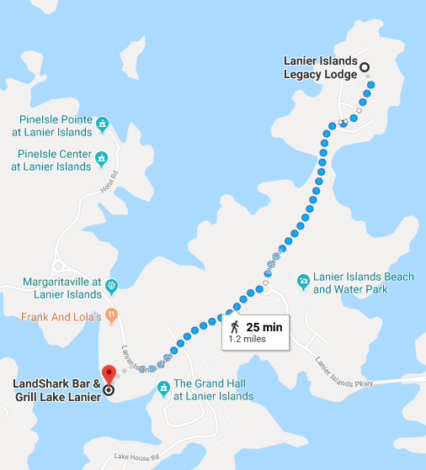

Getting Around

The Legacy Lodge provides a free shuttle back and forth to Margaritaville
with regular service and shuttle stops

Villa and Lakehouse guests are also provided complimentary use of a golf cart!

Make Your Reservations Now!

Reservations may be made by calling 770-945-8787
or online by clicking here:
Reserve your room for the APHC 30th Anniversary Celebration

If you have any difficulty booking online
or if the online portal shows that no rooms are available
please call and speak to a reservation agent

The Fine Print

- Our Parrothead rates are available from Wednesday, July 10th to Tuesday, July 16th
- Each room is subject to a Resort Fee of $7.25 per night
  - The resort fee covers the Lanier Islands entrance gate fee (saving you $15 per day per vehicle!) and also provides for daily valet or self-parking and in-room wireless high-speed internet among other amenities
- Guests entering Lanier Islands should tell the gatehouse they are staying at the Legacy Lodge to avoid the per-vehicle gate fee. Note that vehicles arriving on Saturday are still subject to the $10 per person fee for Lanier Islands’ Full-Moon Party

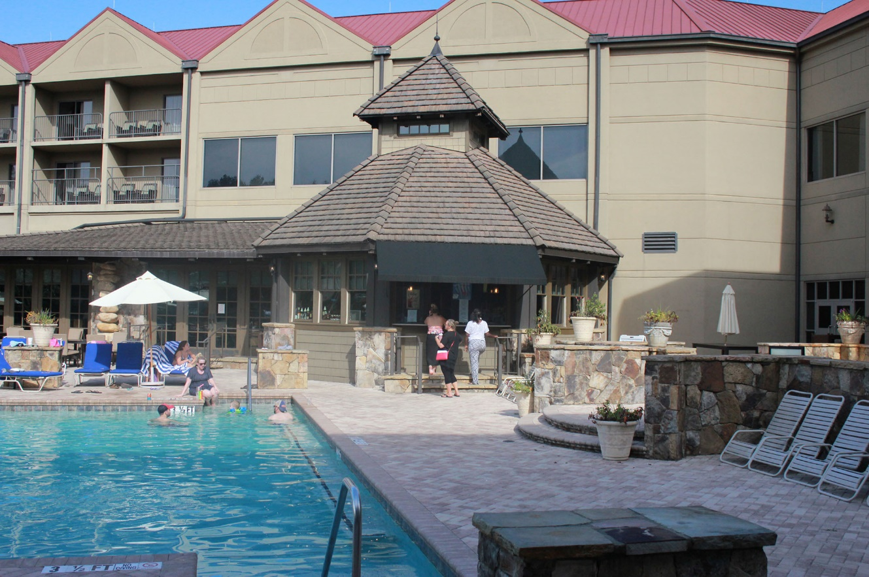
You can Wonder Why We Ever Go Home
during our Sunday pool party featuring Reggie Starrett
Camping

Guest may also choose to camp at the brand new
Margaritaville Waterfront RV Resort

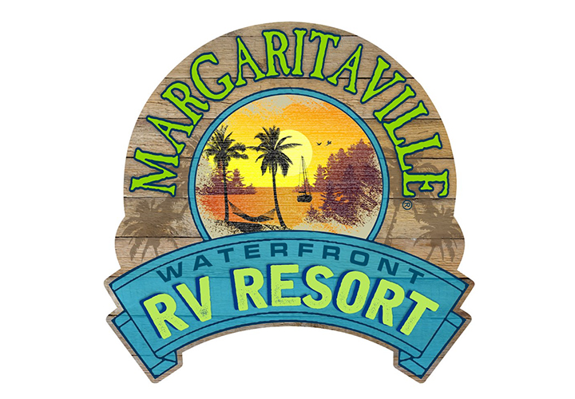

The rate is $75 per night and includes showers, Wi-Fi, and full hookups
Click here and make one of the campsites below your One Particular Harbor

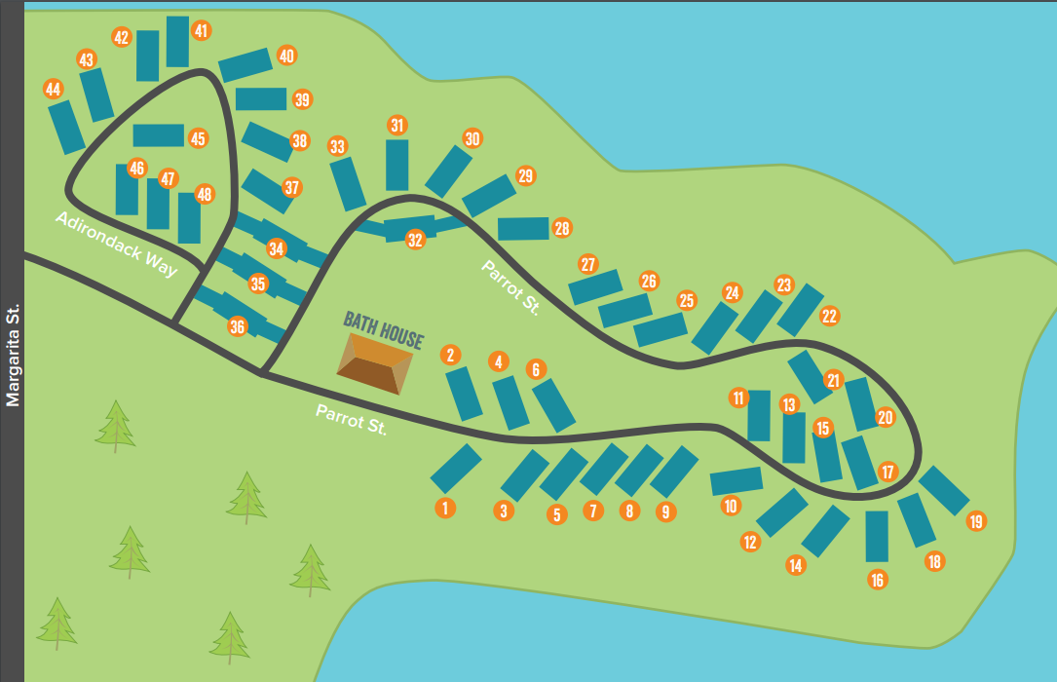

May 5, 2019 Update: The reserved parrot head rooms and rates at our host hotel are sold out

Legacy Lodge Availability:
The Legacy Lodge itself is completely sold out for Friday, July 12th
The Lodge still has availability for Saturday, July 13th at regular reservation rates
A spot check showed Lodge Double rooms starting at $239/night and Lodge King rooms starting at $259/night

To reserve a room for Saturday you may call 770-945-8787
or use the regular reservation link: Legacy Lodge Regular Reservations
The Lodge also still has good availability for the preceding Wednesday and Thursday, and for Sunday, July 14th

Villa and Lakehouse Availability:
There are still Villa and Lakehouse rooms available
for Friday, July 12th and Saturday, July 13th at regular reservation rates.
A spot check showed Villa rooms starting at $259/night and Lakehouses starting at $499/night

To reserve a room for Friday and Saturday you may call 770-945-8787
or use the regular reservation link: Legacy Lodge Regular Reservations

Camping Availability:
There are still plenty of campsites available!

Alternate Options:
Miles to Margaritaville | Hotel | Address | Phone # | Web Site
5.7 | Holiday Inn Express & Suites Buford NE | 4951 Bristol Industrial Way, Buford, GA 30518 | (678) 730-5050 | www.ihg.com
9.3 | Hampton Inn & Suites Flowery Branch | 4660 Holland Dam Rd, Flowery Branch, GA 30542 | (770) 965-0357 | www.hamptoninn3.hilton.com
10.6 | Holiday Inn Express & Suites Buford-Mall Of GA | 2499 Satellite Blvd, Buford, GA 30518 | (678) 318-1080 | www.ihg.com
11.2 | Americas Best Value Inn Buford/Mall of Georgia | 4267 Buford Dr, Buford, GA 30518 | (770) 932-0111 | www.redlion.com
12.2 | Hampton Inn Atlanta-Mall Of GA | 3240 Buford Dr, Buford, GA 30519 | (678) 546-1200 | www.hamptoninn3.hilton.com
12.9 | Courtyard by Marriott Atlanta Buford Mall of Georgia | 1405 Mall of Georgia Blvd, Buford, GA 30519 | (678) 745-3380 | www.marriott.com
12.9 | Country Inn & Suites by Radisson, Buford at Mall of Georgia | 1395 Mall of Georgia Blvd, Buford, GA 30519 | (770) 271-1441 | www.countryinns.com
12.9 | Fairfield Inn & Suites by Marriott Atlanta Buford/Mall of Georgia | 1355 Mall of Georgia Blvd, Buford, GA 30519 | (678) 714-0248 | www.marriott.com
13.9 | Quality Inn | 3469 Mundy Mill Rd, Oakwood, GA 30566 | (770) 287-1000 | www.choicehotels.com
14 | Best Western Plus Lake Lanier Gainesville Hotel & Suites | 4535 Oakwood Rd, Oakwood, GA 30566 | (770) 535-8080 | www.bestwestern.com
14.4 | Jameson Inn Oakwood | 3530 Thurmon Tanner Pkwy, Oakwood, GA 30566 | (770) 533-9400 | www.stayinns.com

Please remember that Guests entering Lanier Islands are subject to a $15/day vehicle fee. If you are staying at the Lodge, Villa or Lakehouse Let the gatehouse know to avoid the per-vehicle gate fee. Also, vehicles arriving on Saturday are also subject to the $10 per person fee for Lanier Islands’ Full-Moon Party.

